2022 Spartan Invite
Welcome to the 17th Annual Spartan Invitational on Friday October 7, 2022 at Bear Creek Park East.
- Address: 2002 Creek Crossing Street, Colorado Springs, CO 80905
- Parking is tight, Car Pool if at all possible. Use the parking lots on the west side of 21st street up by sports fields.
  - BUS PARKING Busses will drop athletes off within the park then will leave the park to go to bus parking located in at Penrose Event Center Southwestern most parking area at 1045 Lower Gold Camp Road.
  - ACTIVITY BUS and Handicapped parking only within Bear Creek Park East, entering at Creek Crossing.
  - SPECTATORS park on West side of 21st at the athletic fields, Penrose equestrian center (walk Southwest from the parking lot to the race, 400 meters) , or in the neighborhoods North of the park. NO COST FOR PARKING
  - NO PARKING AT DOG PARK. NO SPECTATOR PARKING WITHIN THE PARK EXCEPT HANDICAPPED PARKING.
- Transportation is not provided by D11, so you will have to make arrangements for your own transportation. We will discuss early dismissal times at practice once final teams are assigned.
Meet Schedule
2:30 p.m. Girls JV
3:15 p.m. Boys JV
3:45 p.m. Girls Varsity
4:15 p.m. Boys Varsity
5:00 p.m. Awards
Course Map

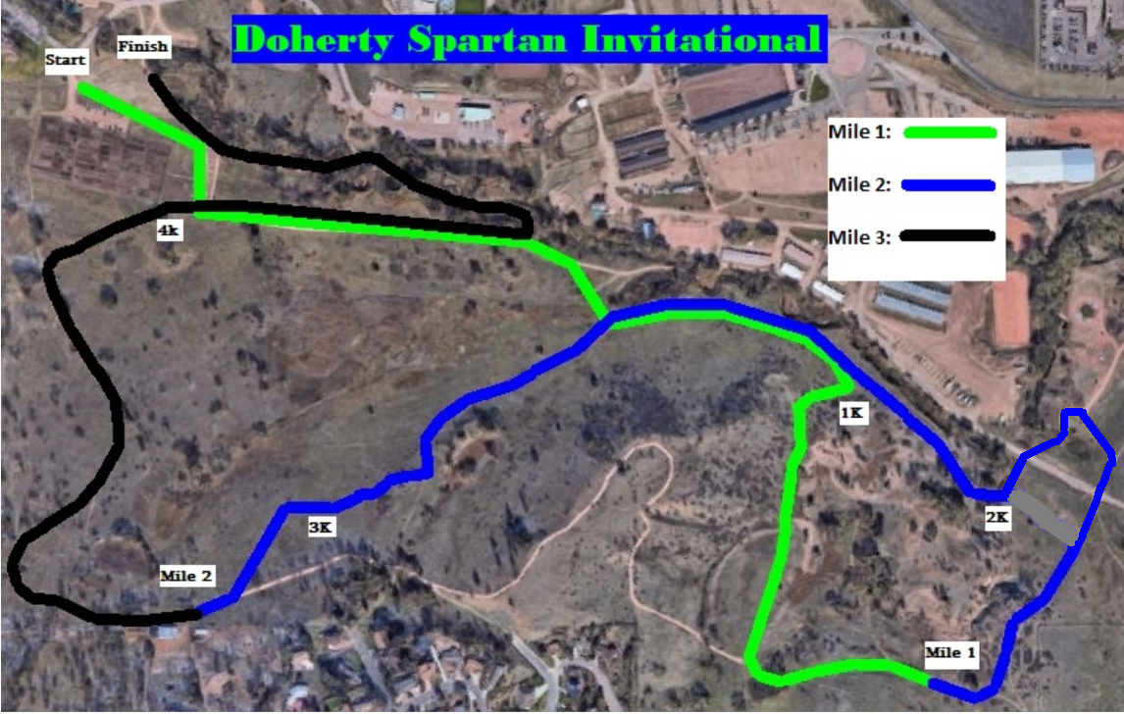

Parking Map
